**Lab Assignment No: 14**

**NAME:** Takankhar Shubham

**ROLLNO:** 54

**SUBJECT CODE**: IT8002

**SUBJECT NAME**: CPP AND JAVA

**GR NO:** 119C0054

**BATCH:** B3

**PROBLEM STATEMENT:1:- Print percentage and class(Ist class, IInd class,fail) of student by entering marks.**

**CODE:**

import java.util.Scanner;

public class student {

private static Scanner sc;

public static void main(String[] args)

{

int totalSubjects, i;

float Marks, total = 0, Percentage;

sc = new Scanner(System.in);

System.out.print(" Please Enter the Total Number of Subjects : ");

totalSubjects = sc.nextInt();

System.out.print(" Please Enter the Subjects Marks : ");

for(i = 0; i < totalSubjects; i++)

{

Marks = sc.nextInt();

total = total + Marks;

}

Percentage = (total / (totalSubjects * 100)) * 100;

System.out.println(" Total Marks = " + total);

System.out.println(" Marks Percentage = " + Percentage);

System.out.print("The student Grade is: ");

if(Percentage>=75)

{

System.out.print("First Class");

}

else if(Percentage>=40 && Percentage<75)

{

System.out.print("Second Class");

}

else

{

System.out.print("Fail");

}

}

}

**OUTPUT:**

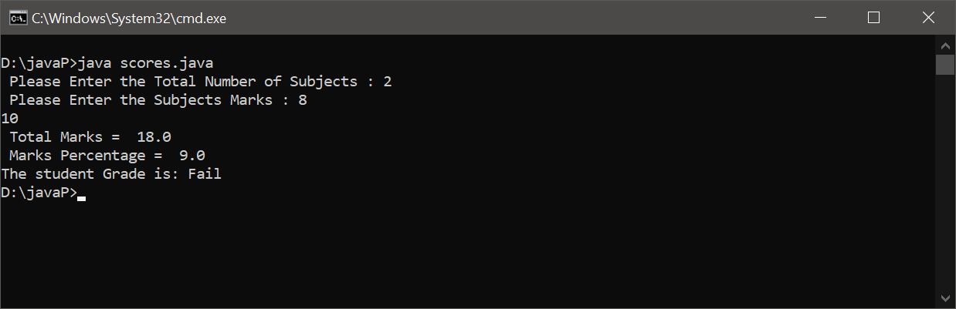

**PROBLEM STATEMENT:2**:- **Swap two numbers using user defned class.**

**CODE:**

import java.util.*;

class swapno {

public static void main(String[] args) {

int x, y, t;

Scanner sc = new Scanner(System.in);

System.out.println("Enter the value of X and Y");

x = sc.nextInt();

y = sc.nextInt();

System.out.println("before swapping numbers: "+x +" "+ y);

t = x;

x = y;

y = t;

System.out.println("After swapping: "+x +" " + y);

System.out.println( );

}

}

**OUTPUT:**

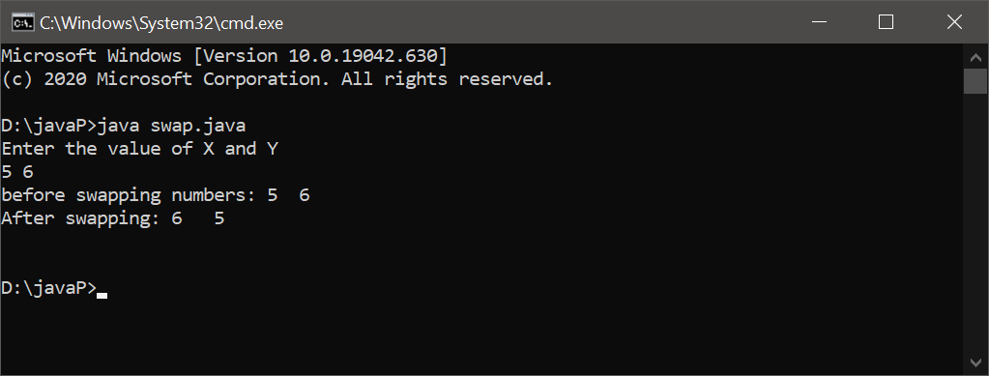

**PROBLEM STATEMENT:3:- Print fibonacci series using user defined package.**

**CODE:**

package fibonacci;

public class fibo{

public static void main(String[] args) {

int n = 100, t1 = 0, t2 = 1;

System.out.print("Upto " + n + ": ");

while (t1 <= n)

{

System.out.print(t1 + " + ");

int sum = t1 + t2;

t1 = t2;

t2 = sum;

}

}

}

